Tweet Sheet

Azure Site Recovery and Backup

How to use

During your six-week Azure Business Continuity campaign, you will send out a Tweet every day. We’ve given you a daily Tweet, plus 7 images to get you started.

You’ll need to reuse or create other images, videos or animated GIFs to post with your Tweet, or you can post without. We’ve also given you some ideas for your Call-to-Action (CTA). Use the one that fits your offer. Feel free to customize any of the Tweets to match your value prop and audience.

Week 1 | Day | Tweet | CTA  (TBD) | Char #  w/o CTA
This | 1 | Get bottomless, affordable backup for your applications, there when you need it. We’ll show you how. (Retweet Week 3/Day 3) |  | 100
 | 2 | Is your disaster recovery plan all it should be? Don’t underestimate the risk, it could cost you thousands. (Retweet Week 5/Day 1) |  | 107
 | 3 | Your data and applications are everywhere—on servers, clients, and in the cloud. Protect them with Azure Backup. |  | 113
 | 4 | Your organization needs a disaster recovery strategy to keep data safe during downtime. (Retweet Week 3/Day 5) |  | 118
 | 5 | We help businesses use the cloud to forecast, manage, and respond quickly to change. (Retweet Week 6/Day 2) |  | 85
Week 2 | Day | Tweet | CTA  (TBD) | Char #  w/o CTA
 | 1 | Protect your data automatically with policies you set for Hyper-V, VMware and physical servers. It’s in the cloud. (Retweet Week 4/Day4) |  | 114
 | 2 | Imagine your site has an outage at the primary datacenter. Once you’ve stopped screaming, contact us. We can help. (Retweet Week 5/Day 4) |  | 115
 | 3 | How easy is site recovery? A single click recovers an entire application with Azure Automation runbooks. |  | 105
 | 4 | Even an hour of data downtime can cost you thousands. Learn how to protect your business now. (Retweet Week 4/Day 2) |  | 94
 | 5 | Get peace of mind knowing your data is backed up and that you can restore your information quickly with Azure Backup. |  | 116
Week 3 | Day | Tweet | CTA  (TBD) | Char #  w/o CTA
 | 1 | Data loss from hacking or hardware failure can be significant. You need a disaster recovery plan to backup and restore data. |  | 125
 | 2 | Do you need continuous access to your data? Don’t lose critical data that can cost your business thousands. (Retweet Week 6/Day 4) |  | 107
 | 3 | Get bottomless, affordable backup for your applications, there when you need it. We’ll show you how. |  | 100
 | 4 | Tired of tape backups? Azure Backup is a compelling alternative with cost savings and up to 99 years of retention. (Retweet Week 5/Day 2) |  | 115
 | 5 | Your organization needs a business continuity and disaster recovery (BCDR) strategy to keep data safe during downtime. |  | 118
Week 4 | Day | Tweet | CTA  (TBD) | Char #  w/o CTA
 | 1 | Azure Site Recovery allows you to replicate workloads, avoiding the need for a secondary site. Reduce your costs and complexity. |  | 128
 | 2 | Even an hour of data downtime can cost you thousands. Learn how to protect your business now. |  | 93
 | 3 | A good disaster recovery plan keeps your apps and data available during planned and unplanned downtime, with fast recovery. (Retweet Week 6/Day 1) |  | 124
 | 4 | Protect your data automatically with policies you set for Hyper-V, VMware and physical servers. It’s in the cloud. |  | 114
 | 5 | Give your data growing room by automatically archiving inactive data from on-premises to the cloud. Ask us how. |  | 112
Week 5 | Day | Tweet | CTA  (TBD) | Char #  w/o CTA
 | 1 | Is your disaster recovery plan all it should be? Don’t underestimate the risk, it could cost you thousands. |  | 107
 | 2 | Tired of tape backups? Azure Backup is a compelling alternative with cost savings and up to 99 years of retention. |  | 115
 | 3 | Will your business fail if there’s a man-made or natural disaster? Make sure you have a business continuity plan in place. |  | 122
 | 4 | Imagine your site has an outage at the primary datacenter. Once you’ve stopped screaming, contact us. We can help. |  | 113
 | 5 | By using software policies instead of tape rotations, get immediate data availability even during a full disaster recovery. |  | 123
Week 6 | Day | Tweet | CTA  (TBD) | Char #  w/o CTA
 | 1 | A good disaster recovery plan keeps your apps and data available during planned and unplanned downtime, with fast recovery. |  | 125
 | 2 | We help businesses use the cloud to forecast, manage, and respond quickly to change. |  | 84
 | 3 | Does the thought of a natural or man-made disaster shutting down your business worry you? We can help. |  | 102
 | 4 | Do you need continuous access to your data? Don’t lose critical data that can cost your business thousands. |  | 107
 | 5 | Secure, compliant, and reliable business continuity for businesses that don’t have time to be offline. |  | 102

CALL TO ACTION (CTA)

Select a call to action for each of the Tweets. Customize it to your offer. The highlighted CTAs are the ones that will have greater impact.

Number | CTA | Characters | Use this
1 | Download the eGuide | 19 | Link directly to a gated or open eGuide (eGuide will link to a contact us)
2 | Contact us | 10 | Link to a web page with contact information
3 | Join our webinar | 16 | This CTA should be used 2 or more times a week. You can mix it up with a Contact Us and/or Download eGuide/ Sign up for newsletter
4 | Learn more | 11 | Blog post or link to a gated eGuide
6 | Find out how | 12 | Link to eGuide, gated or just on website, or to a contact us page
7 | Newsletter sign-up | 18 | This, the contact us and the webinar are 3 #1 CTAs.

Image Use

Use our images or create your own. We’ve included links to the original images if you want to change the text or the fonts. We used the Raleway font for the text on most images.
Before using, double-check the copyright on the image, as it could change over time.

Image | Image link
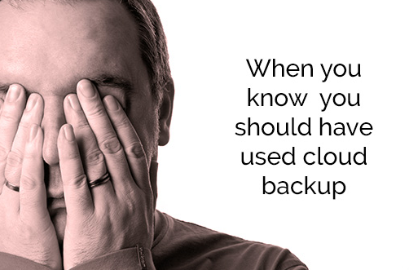 | https://morguefile.com/search/morguefile/6/fear/pop
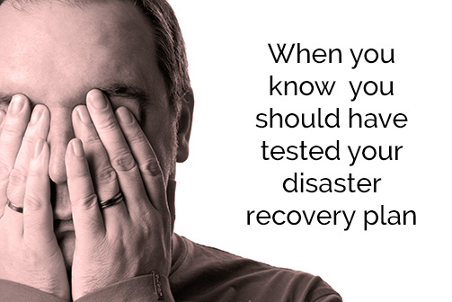 | https://morguefile.com/search/morguefile/6/fear/pop
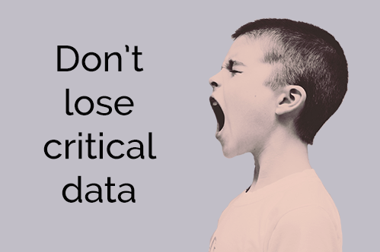 | https://unsplash.com/search/scream?photo=ASKeuOZqhYU
 | https://unsplash.com/search/train?photo=XdWa8DUO-E4
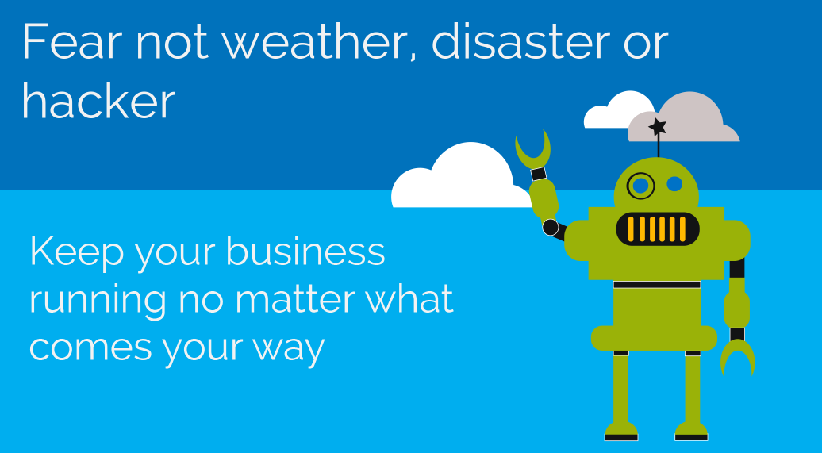 | No image source, created for this campaign for partners.
Image on left: https://unsplash.com/search/photos/happy?photo=VL_0Z1TJL38

Image on right:
https://morguefile.com/search/morguefile/22/sad/pop
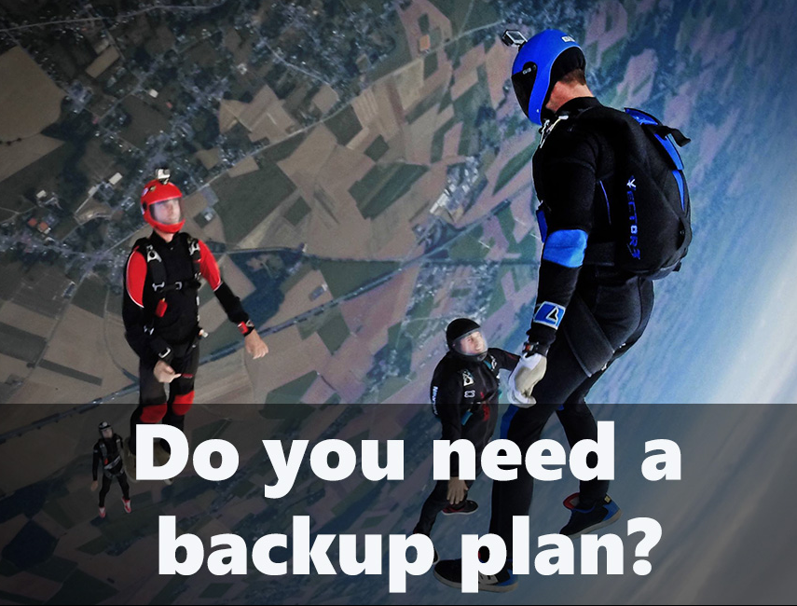 | https://unsplash.com/search/skydiving?photo=guDkXldTxy8

